2026 MG NATIONAL MEETING – HAHNDORF

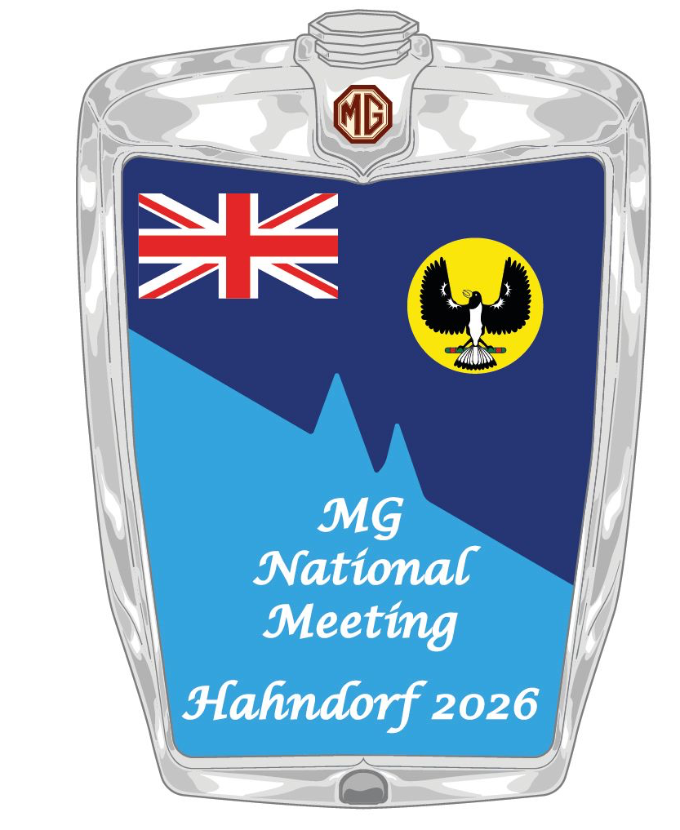

National Bulletin #6 – February 2026

Hello again and we’re really getting to the pointy end now! At the time of writing this (early February) there were 240 registrations . . . a reminder that registrations will close when we reach our cap of 300 so if you haven’t yet entered, please get onto it! Note: there will be a Waiting List, in case of later cancellations.
Full details of the National Meeting are on the dedicated event website, 2026mgnationalmeeting.com.au


If you want to go straight to the registration form, the link is Registration Form: 2026 MG National Meeting Hahndorf
Something different for Regalia this year: be prepared for the cool autumn nights with the MG National Meeting Hahndorf 2026 Beanie. Check out the full range of Regalia at MG Car Club of SA | National Meet 2026

A reminder of the program:
- Monday April 27 – Registration; Noggin‘n’Natter/Rocker Cover Racing
- Tuesday April 28 – Concours at the historic Oakbank Racecourse
- Tuesday April 28 - Theme Night Dinner: Magical EveninG
- Wednesday April 29 – Sprint; Discovery Run
- Thursday April 30 – Motorkhana; Kimber Run; Presentation Dinner
- Friday May 1 – Farewell Breakfast.
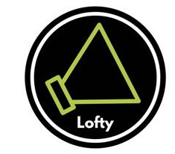
A new feature at the Magical EveninG on Tuesday will be an auction – details to come later.
We’d like to acknowledge our event sponsors: Shannons Motor Insurance; The German Arms Hotel Hahndorf; Karkoo Nursery; Lofty Radio 88.9. Lofty is a local community radio station and they will be giving pre-publicity to the Concours and broadcasting live from that event on the Tuesday morning.
A note/reminder to all Clubs who want to enter the magazine competition. Your hard copies and/or e-bulletins MUST be with the SA Club President, Stephen Marlow, no later than 5pm on Friday March 13th. I will then deliver them all to our judge and she will complete judging by April 10th. Any entry received after March 13th will not be judged.
There are two other events, one either side of the National Meeting, which are proving popular.
These are a Collingrove Hillclimb on April 26th, details at www.sportingcarclub.com.au and the Peter Hall 6 Hour Teams Regularity on May 3rd at Mallala,details www.mscasa.com
Of course, there’s also plenty to do in and around Hahndorf and if you’re still looking for ideas, go to https://southaustralia.com/destinations/adelaide-hills which will give you plenty of ideas of the local attractions.
Any general enquiries about the National Meeting should be made to Tim Edmonds at Chairman2026natmeet@outlook.com
See you at Hahndorf.

